Semester Two Examination 2017 | 
Question/Answer Booklet

PHYSICS

12 ATAR

Student  Number: | In  Figures | 
 | In words

Time allowed for this paper
Reading time before commencing work: Ten minutes
Working time for paper: Three hours

Materials required/recommended for this paper

To be provided by the supervisor

This Question/Answer Booklet/Formulae and Data Booklet

To be provided by the candidate
Standard items: pens (blue/black preferred), pencils (including coloured), sharpener, correction tape/fluid, eraser, ruler and highlighters
Special items: non-programmable calculators approved for use in this examination, drawing templates, drawing compass and a protractor

Important note to candidates

No other items may be taken into the examination room. It is your responsibility to ensure that you do not have any unauthorised material. If you have any unauthorised material with you, hand it to the supervisor before reading any further.

Structure of this paper
Section | Number of questions available | Number of questions to be answered | Suggested working time (minutes) | Marks available | Percentage of exam
Section One: Short answers | 11 | 11 | 50 | 53 | 30
Section Two: Problem-solving | 7 | 7 | 90 | 91 | 50
Section Three: Comprehension | 2 | 2 | 40 | 36 | 20
 |  |  |  | Total | 100

Instructions to candidates

- The rules for the conduct of the Western Australian Certificate of Education ATAR course examinations are detailed in the Year 12 Information Handbook 2017. Sitting this examination implies that you agree to abide by these rules.

- Write your answers in this Question/Answer booklet.

- When calculating or estimating answers, show all your working clearly. Your working should be in sufficient detail to allow your answers to be checked readily and for marks to be awarded for reasoning.

In calculations, give final answers to three significant figures and include appropriate units where applicable.

In estimates, give final answers to a maximum of two significant figures and include appropriate units where applicable.

- You must be careful to con ne your answers to the specific questions asked and to follow any instructions that are specific to a particular question.

- Additional working space pages at the end of this Question/Answer booklet are for planning or continuing an answer. If you use these pages, indicate at the original answer, the page number it is planned/continued on and write the question number being planned/continued on the additional working space page.

- The Formulae and Data booklet is not to be handed in with your Question/Answer booklet.

Additional Data

Table of common mesons

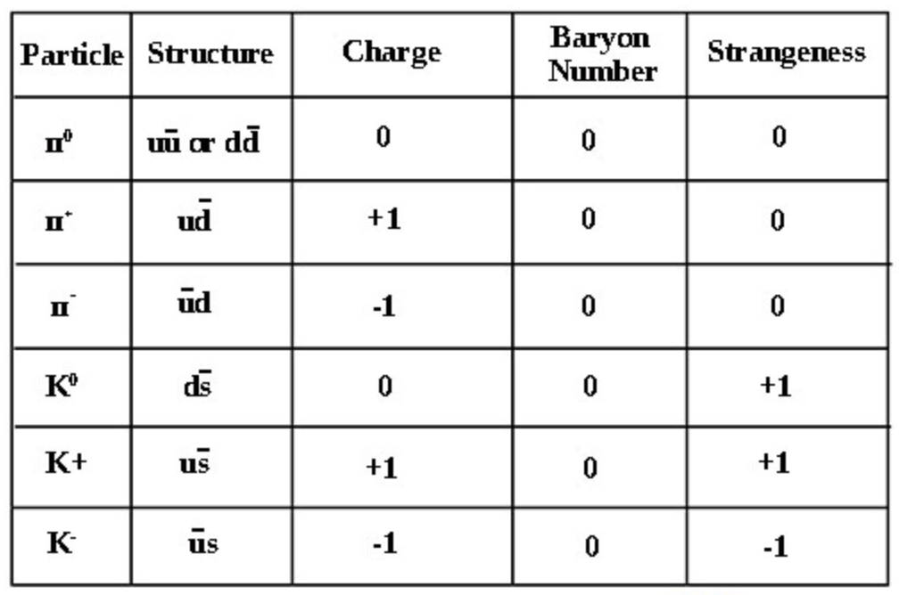

Redshift and recessional velocity

 | 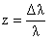 | It can also be shown that: | 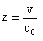

Where: z = redshift
Δλ = change in wavelength (moving source) (nm)
λ = wavelength of stationary source (nm)
v = recessional speed of galaxy (ms⁻¹)
c₀ = speed of light in a vacuum (ms⁻¹)

Hubble’s Law

V_{galaxy} = recessional speed of galaxy (ms⁻¹)
d = distance to galaxy (Mpc)
H_{o} = Hubble’s constant (Kms⁻¹Mpc⁻¹)

Section One. Short response. 30% (53 Marks)

This section has 11 questions. Answer all questions. Write your answers in the spaces provided.

When calculating numerical answers, show your working or reasoning clearly. Give final answers to three significant figures and include appropriate units where applicable.

When estimating numerical answers, show your working or reasoning clearly. Give final answers to a maximum of two significant figures and include appropriate units where applicable.

Additional working space pages at the end of this Question/Answer booklet are for planning or continuing an answer. If you use these pages, indicate at the original answer, the page number it is planned/continued on and write the question number being planned/continued on the additional working space page.

Suggested working time: 50 minutes.
________________________________________________________________

1. The distance between the proton and the electron in the ground state of the hydrogen atom is defined as the Bohr radius. Given that the Bohr radius can be measured as r = 5.29 x 10⁻¹¹ metres, calculate the speed with which the electron circles the nucleus. [5 marks] | 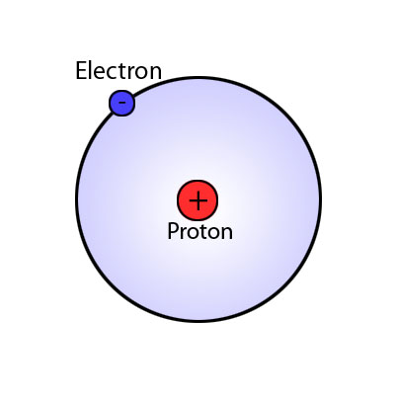

2. Consider the decay equation shown here showing the hadronic process of lambda decay.  Note: Λ = uds, p = uud, π⁻ = du | 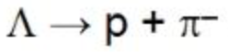

- Show that charge and baryon number are conserved. [2 marks]

Charge
Baryon number

- Is strangeness conserved? All working must be shown to explain your answer.
[3 marks]

3. A wire is conducting a DC current of 1.50 A. At point X a magnetic flux density of 3.86 x 10⁻⁶ T is detected. Calculate the distance between the current carrying wire and point X. You can ignore the effects of the Earth’s magnetic field in this question.  [2 marks] | 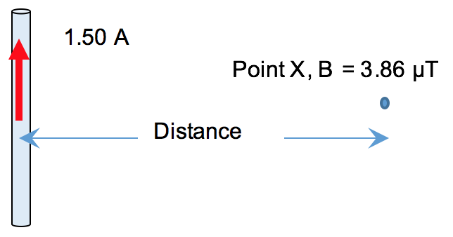

4. A proton has been accelerated to 95% of the speed of light in the Large Hadron Collider (LHC). Calculate its energy. [3 marks]

5. The diagram shows a uniform ladder of mass 20 kg and length 5.00 m resting on firm ground and against a frictionless wall. Friction acts at the base of the ladder from the ground as shown to stop the ladder collapsing. The force from the wall (F_{wall}) and friction both act in the horizontal and are in equilibrium. A person of mass 80.0kg is standing on the ladder 3.50 m from the base. A normal reaction force at the base of the ladder and the two weight forces act in the vertical direction on the ladder.  The ladder makes an angle of 65.0⁰ with the ground | 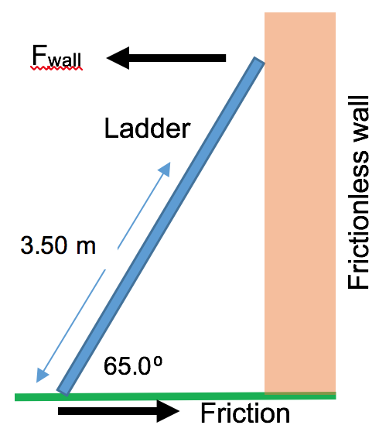

- Calculate the force of friction acting on the ladder in the position shown. [4 marks]

- If the angle that the ladder makes to the horizontal is changed to 45⁰ how would this change the magnitude of friction required to maintain equilibrium. The friction would:

 | Increase | Stay the same | Decrease | Insufficient data to determine

Circle a response and explain your choice: [3 marks]

6. A subatomic particle consisting of a quark-antiquark pair, has a rest-life measured to be 2.34x10⁻⁸ seconds in the laboratory. What is the speed of the same particle, if its average lifetime is measured to be 3.95x10⁻⁸ seconds, in a cosmic ray experiment? [6 marks]

7. The light received from many distant galaxies is red-shifted.

- State the cause of this red-shift, use a diagram to explain your answer. [3 marks]

- A spectral line of light from a laboratory source has a wavelength of 658 nm. The wavelength of this line of light from a distant galaxy (NGC5128) is 670 nm. Calculate the recessional speed of NGC5128. [2 marks]

- Given that a current value for Hubble’s constant is 72kms⁻¹Mpc⁻¹, how far is the observer from NGC5128? [2 marks]

8. Consider the table of elementary particles shown below.

- Write the missing headings in the spaces provided. [2 marks]

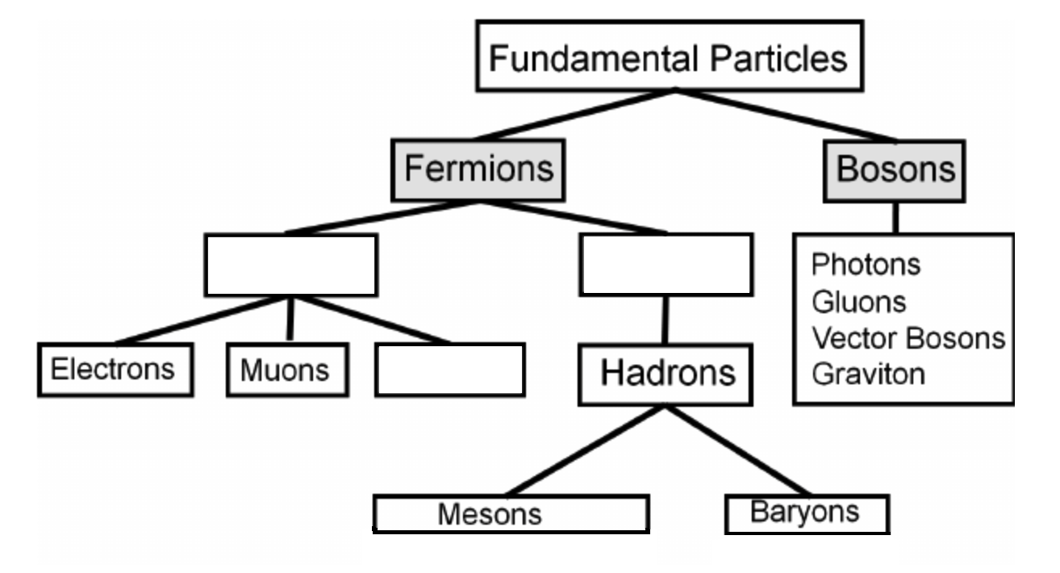

- Briefly explain the difference between mesons and baryons. [2 marks]

9. Explain what is meant by the term, “Ultraviolet catastrophe”. [3 marks]

10. An AC Generator has an armature with an area of 4.7x10⁻² m². The coil rotates from vertical to horizontal in 25ms, through a magnetic field strength of 0.43T. | 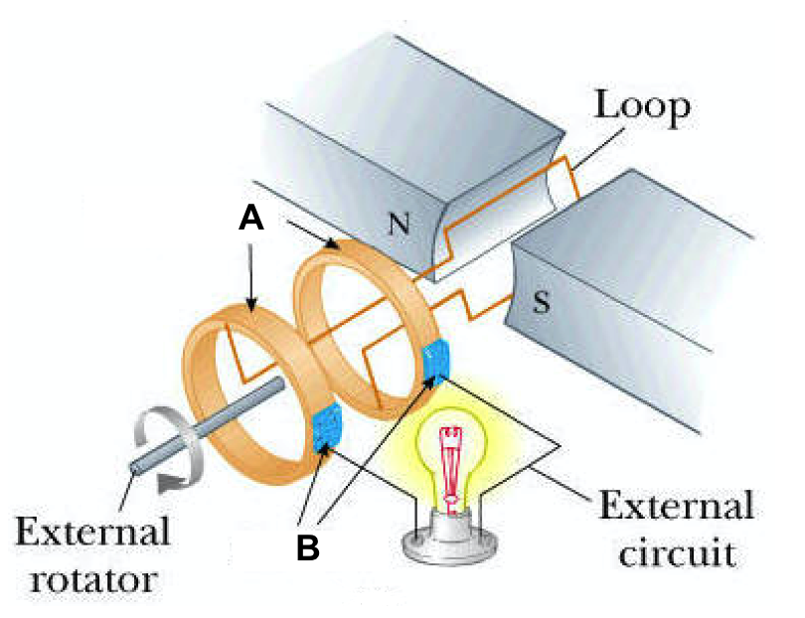

- Identify the parts ‘A’ and ‘B’ shown in the diagram. [1 mark]

Part ‘A’ |  | Part ‘B’

- How many loops must the coil contain in order to generate a potential difference (V_{max}) of 175 volts? [3 marks]

11. A photoelectric effect experiment was performed in which a monochromatic light beam was shone onto a clean metal surface. The wavelength of the incident beam was varied and the maximum kinetic energy of the emitted photoelectrons was recorded in the table below.

 | Wavelength (nm) | Frequency (Hz) | KE_{max} (eV) | KE_{max} (J)
 | 750 | 4.00x10¹⁴ | 0.22 | 3.52x10⁻²⁰
 | 587 |  | 0.67
 | 506 |  | 0.98
 | 444 |  | 1.35
 | 400 | 7.50x10¹⁴ | 1.63 | 2.61x10⁻¹⁹

- Briefly explain the significance of the photoelectric effect to modern physics.
[2 marks]

- Complete the table for the missing values. [2 marks]

- By making use of the data from the table, calculate the work function of the clean metal surface used during this experiment. [3 marks]

Section Two. Problem-solving. 50% (91 Marks)

This section has 7 questions. Answer all questions. Write your answers in the spaces provided.

When calculating numerical answers, show your working or reasoning clearly. Give final answers to three significant figures and include appropriate units where applicable.

When estimating numerical answers, show your working or reasoning clearly. Give final answers to a maximum of two significant figures and include appropriate units where applicable.

Additional working space pages at the end of this Question/Answer booklet are for planning or continuing an answer. If you use these pages, indicate at the original answer, the page number it is planned/continued on and write the question number being planned/continued on the additional working space page.

Suggested working time: 90 minutes.

12. A car of mass 2.20x10³ kg is in horizontal circular motion on a banked track. The car has a speed of 14.0 ms⁻¹ and is relying on friction to stay at a fixed height on the banked track. The radius of the circle is 32.0 m. The track is banked at an angle of 20.0⁰ to the horizontal. Friction acts from the track onto the car parallel to the track as shown. | 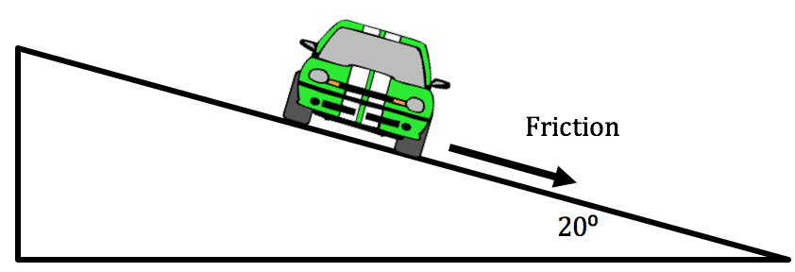

- Construct a vector diagram to the right of the diagram above. Show the forces acting on the car and the net force. [2 marks]

- Calculate the magnitude of friction acting on the car from the banked track. [5 marks]

13. Our Sun is a medium sized star that is part of a spiral galaxy called the Milky Way. Like all spiral galaxies, the stars in the Milky Way rotate around a galactic centre. The Sun’s orbit is virtually circular with a radius of 2.50x10²⁰ m (about 26 000 light years); its average orbital speed is about 2.20x10⁵ ms⁻¹.

Calculate the orbital period of the Sun around the galactic centre of the Milky Way
(in years). [4 marks]

Calculate the gravitational field strength due to the Milky Way galaxy at the Sun’s distance from the galactic centre. [3 marks]

The circular orbit of the Sun around the galactic centre of the Milky Way is due to the gravitational force of attraction between the Sun’s and Milky Way’s centres of mass. Use the data provided and answers calculated thus far to show that the mass of our galaxy inside our Sun’s orbit must be about 1.80x10⁴¹ kg.

(If you could not calculate an answer to part (a), use 7.00x10¹⁵ s; if you could not calculate an answer to part (b), use 1.90x10⁻¹⁰ Nkg⁻¹) [3 marks]

If the mass of our Sun can be considered to be an average mass for the stars in our galaxy, estimate how many stars there must be inside our Sun’s orbit in the Milky Way. Show your working. [2 marks]

The mass of the Milky Way inside our Sun’s orbit is about 1.80x10⁴¹ kg, which is about 10¹¹ times the mass of our Sun. However, when scientists estimate the mass of the visible matter inside the Sun’s orbit, it only comes to about 10¹⁰ times the mass of our Sun.

(i) What does this imply about the types of matter in our Galaxy? [2 marks]

(ii) If the mass of our galaxy was only 10¹⁰ times the mass of our Sun, describe one (1) effect this would have on our Sun’s motion. [1 mark]

14. A stone of mass 52.0g is thrown from a building of height 30.0m. The stone is launched with an angle of elevation of 38.0⁰ above the horizontal. It takes a time of 3.15s for the stone to reach ground level. You can ignore air resistance for this question.

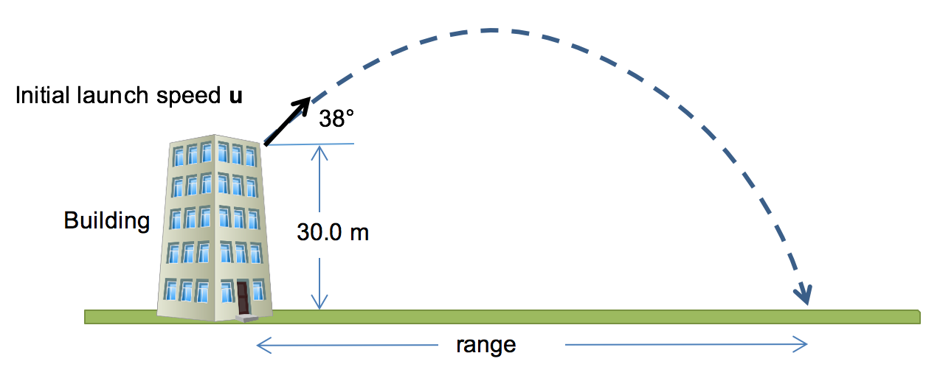

- Calculate the initial launch speed u of the stone. [4 marks]

[For the following calculations, use a numerical value of 9.50ms⁻¹ for the initial launch speed of stone if you could not calculate an answer for part (a).]

- Calculate the horizontal range of the stone. [2 marks]

Calculate the velocity of the stone after 2.50s of flight. You must give a magnitude and direction. [5 marks]

- Calculate the work done on the stone by the Earth’s gravitational field in the motion from launch to reaching ground level. [2 marks]

15. A nature lookout consists of an elevated concrete walkway high above the ground. A uniform platform has been constructed so people can walk out over a gorge and view it. The entire platform structure is shown in the figure shown here. | 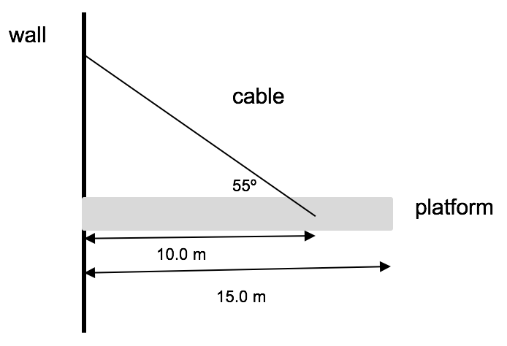

The platform is designed to support a load of 8.50 tonnes and is 15.0m long. A single steel cable supports the platform, attached 10.0m from the end at 55.0° as shown in the figure. The platform has a mass of 0.700 tonnes. The platform is uniform and it can be assumed that – when it is acting - the 8.50 tonne maximum load acts half-way along its length. The steel cable shown has a maximum tensile strength of 1.50x10⁵ N.

- On the diagram above, draw all the forces acting on the platform when in it is an unloaded state as drawn above. Label the forces appropriately. [3 marks]

- Show that with the maximum load acting through the platform’s midpoint, the cable will be able to support the platform. Support your answer with calculations.
[4 marks]

[If you could not calculate an answer for part (a), use a value of 9.00x10⁴ N for the tension in the cable.]
- Hence, calculate the magnitude of the force that the wall exerts on the platform.
[4 marks]

- If the maximum load of 8.50 tonnes is gradually moved towards the end of the platform, describe what happens to the magnitude and direction of the force you calculated in part (c). No calculation is required. [2 marks]

- If the maximum load continues to move towards the end of the platform, the cable will eventually exceed its load limit and snap. Calculate how far towards the edge of the platform the load can move until the load limit on the wire is exceeded.
[3 marks]

16. The diagram shows the side view of a DC electric motor. A square coil is placed flat in the uniform magnetic field between the North and South magnetic poles. Current direction in the coil is shown on the sides adjacent to the magnetic poles. The commutator and carbon brushes are also shown.

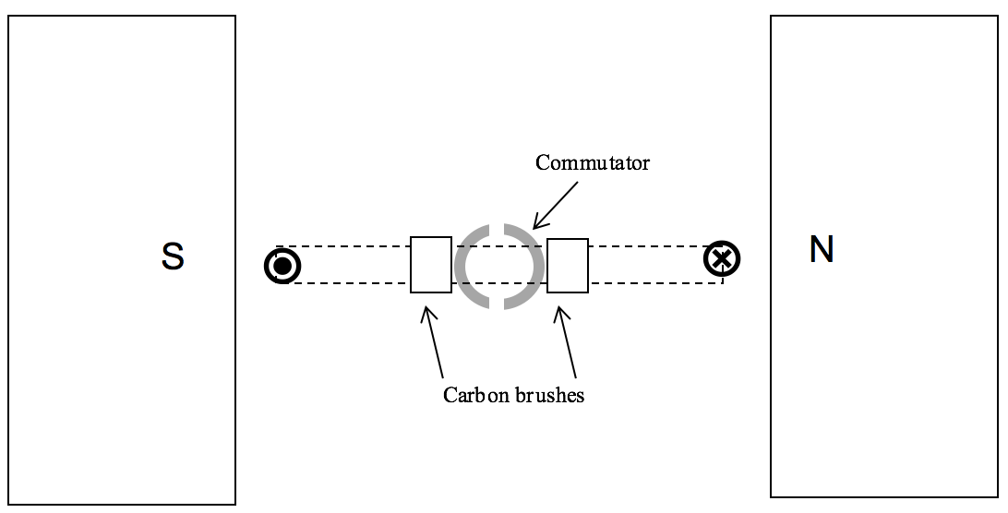

- In which direction will the coil turn from this start position? [1 mark]

- Explain the function of the brushes and the function of the commutator. [3 marks]

- On the diagram above, use the symbols  and  to sketch the location of the coil sides adjacent to the magnetic poles after 30.0º of rotation from this start position. Put arrows on your symbols to indicate the direction of magnetic force acting on them. [2 marks]

- At this new position after 30.0º of rotation from the start position, determine the torque value of the motor as a percentage of maximum torque. [2 marks]

- A single 0.120m length of wire, adjacent to one of the magnetic poles, experiences a 0.0280N magnitude of force when a current of 5.30A is present. Calculate the magnetic flux density between the poles. [2 marks]

- After the motor is switched on, its rate of rotation increases. As this happens, the net current in the coil decreases. Clearly explain why this happens. [3 marks]

17. The trains on the Perth to Fremantle rail line are powered by four 600.0V DC motors. The current is delivered to the motors from the sub-station overhead power lines, which are at a potential of 2.50 x 10⁴V AC. The AC voltage needs to be converted to 600.0V DC by a transformer and inverter.

The overhead lines have a resistance of 2.10Ωkm⁻¹ and the motors each have a resistance of 2.00Ω. When the train is close to the Perth sub-station and operating at full power, the train draws 1.00MW of electrical power.

- Why do overhead transmission lines operate at 25.0kV AC and not at 600.0V DC?
[2 marks]

- What is the current in the overhead lines when the train is close to the Perth sub-station and operating at full power? [2 marks]

- What is the starting current in ONE motor? [2 marks]

- If the train is 20.0km from the sub-station, the power developed by the train will be less than when it is close to the substation. If the train is now drawing 0.700MW and the current drawn from the power lines is 28.0A, what is the voltage available to the motors? [6 marks]

18. Consider the following diagram that shows the same collection of minerals in (a) daylight and (b) “black light”.

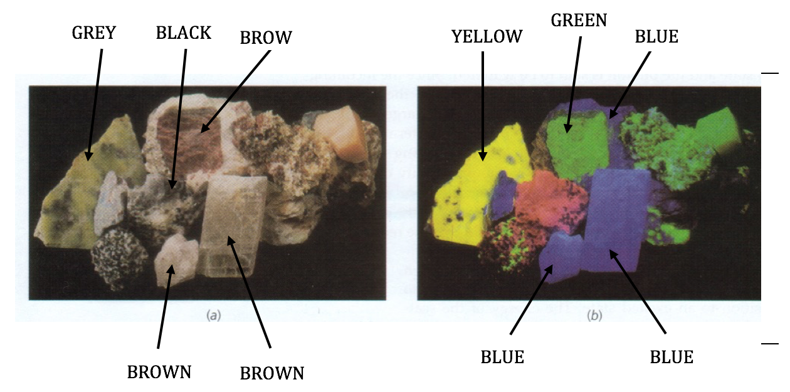

- Complete the following sentence: [2 marks]

The correct terminology for “black light” is
and the phenomenon is called

- The first 4 energy levels for a potassium mineral are shown (not to scale) as follows.

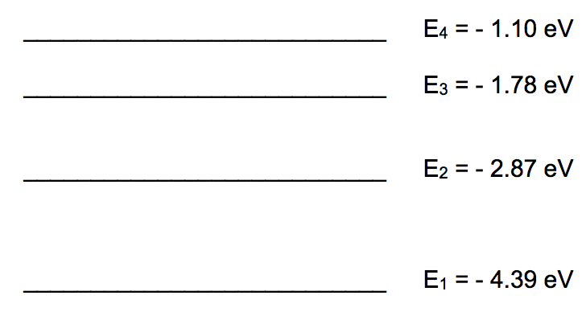

Could a sample of this potassium mineral display the phenomenon as shown in (a) above? Justify your answer, showing the necessary calculations. [4 marks]

- Consider again the first 4 energy levels for the potassium mineral in (b). What would be detected if particles of the sample were bombarded by: [4 marks]

- photons of energy 2.65 eV.

- electrons of energy 2.65 eV?

- If an electron was excited from the ground state to the – 1.78 eV level:

- When it returned to the ground state, what would be the frequency of the photon emitted? [3 marks]

- To which region of the electromagnetic spectrum would the photon belong? Support your answer by referring to its wavelength or frequency. [2 marks]

Section Three. Comprehension. 20% (36 Marks)

This section has two (2) questions. You must answer both questions. Write your answers in the spaces provided.

When calculating numerical answers, show your working or reasoning clearly. Give final answers to three significant figures and include appropriate units where applicable.

When estimating numerical answers, show your working or reasoning clearly. Give final answers to a maximum of two significant figures and include appropriate units where applicable.

Additional working space pages at the end of this Question/Answer booklet are for planning or continuing an answer. If you use these pages, indicate at the original answer, the page number it is planned/continued on and write the question number being planned/continued on the additional working space page.

Suggested working time: 40 minutes.

Question 19:  (18 marks) | Particle Physics – Basic principles and techniques

Particle physics is the modern version of the age-old quest to find the smallest particles that cannot be broken down. Particle accelerators are the 'laboratory equipment' in this area of study.  Charged particles can be accelerated in two senses - by their change of direction in circular paths or by increasing their speed. Studies can be made on the radiation that they emit whilst being accelerated or the after effects of collisions between high speed particles.  The cyclotron first came into use in 1928 using a combination of magnetic and electric fields to accelerate particles in a spiral path. Development of this technology led to the synchrotron which uses an evacuated circular tube with many magnets placed around its circumference. | 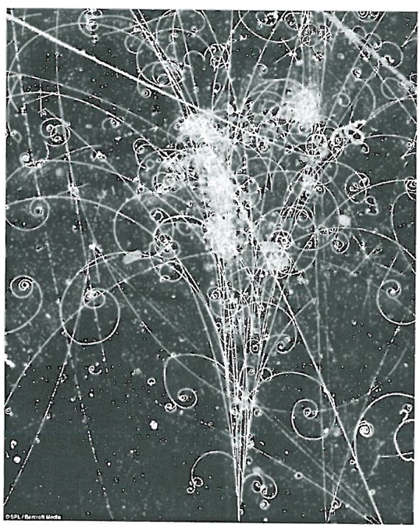

As particles are accelerated the electric field is adjusted and the strength of the magnets is increased to maintain a constant radius and compensate for relativistic effects that become important at high particle energies.

Any charged particle that accelerates will radiate electromagnetic energy. This is true even at a constant speed in a circular path. So, a continual supply of energy is required in synchrotrons to just maintain a constant particle speed let alone increase their speed. The emitted radiation is known as synchrotron radiation and can cover the entire electromagnetic spectrum.

Linear accelerators (LINAC) use a straight path and a series of accelerating voltages as the particles move along the line. LINACs are often used to provide the early stages of acceleration before particles are fed into large synchrotrons.

Collider experiments take two beams of particles that have been separately accelerated in opposite directions and smash them into each other. This is difficult to achieve but if successful it is an efficient use of energy.

When two particles with an equal magnitude of momentum collide head on, the total momentum is zero before and after the collision. If particles are stationary after the collision then their kinetic energy is zero. By the conservation of energy and mass principle, the energy before the collision is transformed into the mass of new particles formed in the collision. The particles that are present after a collision reaction can be different to those that went in. This is exactly what particle physicists aim to achieve and the discovery and study of these new particles underpins their work.

Every collision is governed by one of the fundamental forces (except the force of gravity which has no significant influence on such tiny particles in this context):

- The electromagnetic force leads to simple collisions between charged particles. No new particles are formed when this force is at work.

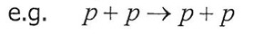

- The strong force dominates reactions between hadrons (which contain quarks)

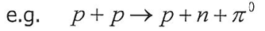

- The weak force is likely to be involved in lepton reactions, especially if one of the leptons is a neutrino.

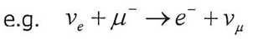

Einstein's theory of special relativity has led us to the idea that the mass of a moving object is not the same as its rest mass (m₀).

The mass of a moving object cannot be measured directly; it must be calculated from a measurement of momentum and velocity. The relativistic equations for momentum and total energy can be found in the Formulae and Data Booklet (Note: These equations are only applicable for non-zero mass)

Relativity has also given us the idea of mass-energy equivalence. In Newton's version of mechanics, a lone particle not influenced by gravity or electromagnetism but moving at a given speed could only have a single form of energy which is kinetic. At rest, it had no energy at all. This is not the case in relativity.

The relationship is described by the equation (EQ1) shown below:

(EQ1)

Photons are packets of energy travelling at the speed of light.

Surprisingly it has been proved that although photons have zero mass they do have momentum.

Particle physics has also proven to be vital in understanding the nature of the universe a few fractions of a second after the Big Bang. The conditions created in the mightiest accelerators are very similar to those that existed when the universe was 10¹² seconds old.

- In what sense can a particle be accelerated if its speed remains constant? Explain.
[2 marks]

- Once a charged particle has been accelerated to a given speed in a circular path, is further energy required to maintain a constant speed? Explain. [2 marks]

- Can electrons and neutrinos be subject to the strong force? Explain. [2 marks]

- If neutrinos are involved in a collision reaction why is it unlikely that this was governed by the electromagnetic force? [1 mark]

- If you hit a ping pong ball with a table tennis bat which of the three fundamental forces described governs this collision? Justify your answer. [2 marks]

- Calculate the momentum of a proton travelling at 95% of the speed of light. The rest mass of a proton is given in the formula and constant sheet. [3 marks]

- Given the equation (Eq. 1) for Einstein's mass-energy equivalence, show that for a particle at rest the equation simplifies to E = kc² where k is a constant. State clearly the physical quantity that k represents. [2 marks]

- From the equation EQ1, express the momentum of a photon with zero mass can be given wE, where w is a constant. State clearly the physical quantity that w represents. [2 marks]

- Calculate the momentum of a photon of 550 nm yellow light. [2 marks]

Question 20:  (18 marks) | The Physics behind the AFP Crime Scene Investigation

Australian Federal Police have isolated an element found in a specimen at a crime scene. They suspect that the element may be sodium or potassium or unknown element X or Y and have asked the forensic laboratory to run tests on the crime scene specimen to identify which one element it consists of.

The laboratory is able to ionise the element to give it a single positive charge. They then accelerate the ions through a potential difference V (measured in Volts) and by use of a velocity filter are able to send ions that have reached their maximum kinetic energy into a mass spectrometer. When the ions enter the mass spectrometer they are acted on by a uniform magnetic field and follow a semi-circular path.

Technicians conduct a series of tests and measure the radius r of circular motion for different values of potential difference used to accelerate the charged ions.

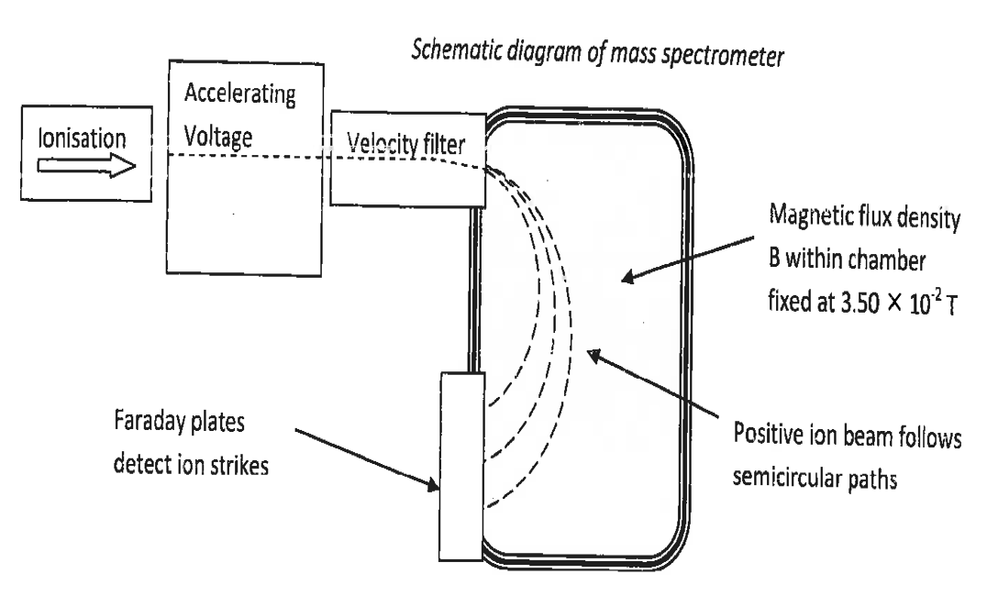

Table 1 (next page) shows the results obtained when the magnetic flux density B in the mass spectrometer was fixed at 3.50 x 10⁻² T.

Potential Diff V  (Volts) | Radius of circular path r  (Metres) | Radius squared r²  (Metres²)
200 | 0.270 $±$ 0.014 | 0.0730 $±$ 0.007
400 | 0.370 $±$ 0.019
600 | 0.490 $±$ 0.025
800 | 0.530 $±$ 0.053
1000 | 0.620 $±$ 0.027
1200 | 0.670 $±$ 0.034 | 0.449 $±$ 0.045

Table 1

It can be shown by an equation on the Formulae and Data Booklet, that the radius r of circular motion for an ion of mass m and charge q, enters the mass spectrometer at speed v and being deflected by a magnetic field of flux density B.

- Use equations on the Formulae and Data Booklet that link the kinetic energy in (Joules) attained by a mass of charge q in a potential difference V to derive or show that:

r² = g(V) | where g is a constant

State clearly the physical interpretation (or quantities) that g represents. [3 marks]

- Complete Table 1 by filling in the values of radius squared r² with the appropriate uncertainty range. Two values have been done for you. [3 marks]

- Plot the data from Table 1 on the grid provided, demonstrating the relationship between radius squared r² (on the vertical axis) and potential difference V (on the horizontal axis). Draw the line of best fit including error bars. [5 marks]



- Calculate the gradient of your line of best fit from your graph showing all working.
[3 marks]

- Use the value of the gradient that you obtained to determine the identity of the charged ion. [4 marks]

Note: If you could not obtain a gradient from part (d), use the numerical value of 8.00x10⁻⁴ for gradient.

You may use the following data:

Mass of a potassium K⁺ ion: = 6.49 x 10⁻²⁸ kg
Mass of sodium Na⁺ ion: = 3.82 x 10⁻²⁶ kg
Mass of X⁺ ion: = 7.84 x 10⁻²⁶ kg
Mass of Y⁺ ion: = Not Available

Additional working space

Question number:



Additional working space

Question number:



Additional working space

Question number:

Additional working space

Question number:

